Gannochy community hall: Guidance notes

THE GANNOCHY TRUST AND THE COMMUNITY HALL
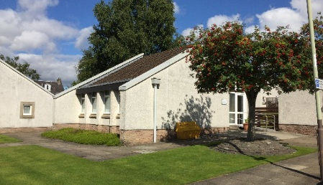
A. K. Bell’s vision to provide affordable quality accommodation for working families of Perth started with the development of the Gannochy Estate in 1923 and the establishment of the Gannochy Trust in 1937. In the 1970’s, the Gannochy Avenue housing programme was launched to provide more pensioners housing. The Gannochy Community Hall formed part of these plans and this work was the first major development of the Gannochy estate since its completion in 1931.

GANNOCHY COMMUNITY HALL – GUIDANCE FOR USE

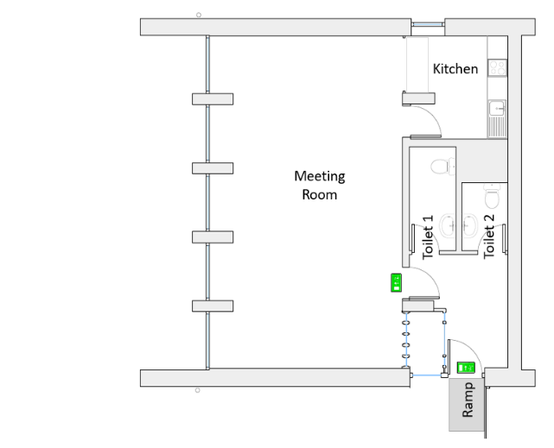
Lettings:
- Fire Exit
- Extinguishers
The Hall provides a welcome space for local groups to run events that benefit the wider community, and for charities supported by the Trust. There is no charge for these groups provided the events are not for commercial gain. Gannochy residents may book the Hall for private events at a rate of £15 per session. Other agencies may book the Hall for non-commercial events at a rate of £30 per session.

Facilities:
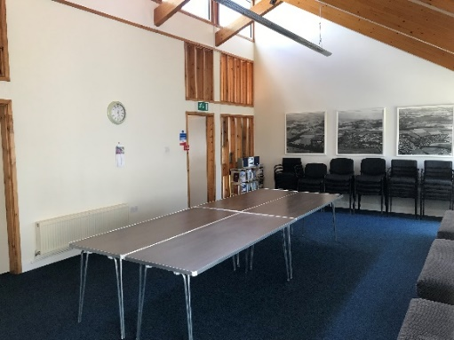
The Hall will accommodate a maximum of 35 people standing or seated in a theatre style. This must not be exceeded. There is a meeting room, kitchen and two toilet facilities. There are five small tables seating four each, and four trestle tables seating eight each. There are 31 seats and three fixed benches at the windows that can accommodate three each. The kitchen has a sink, oven, fridge, hob and kettles. There is a plentiful supply of cups, plates, and cutlery. There is currently no microwave. You should bring all other food preparation equipment that you may need. Regular users of the Hall keep some refreshments in the cupboards - please don’t use them.

Neighbours:
The Hall is situated in the middle of one of the Gannochy Estate’s pensioners’ housing areas. Please note that the grassed areas surrounding the Hall form part of the tenants’ grounds and are not available for letting. Users must respect the privacy of tenants and their environs. We ask you to keep noise levels down when entering and leaving the building. Please ensure that evening events vacate the building by 9pm.

THE GANNOCHY TRUST AND THE COMMUNITY HALL

Cleaning:
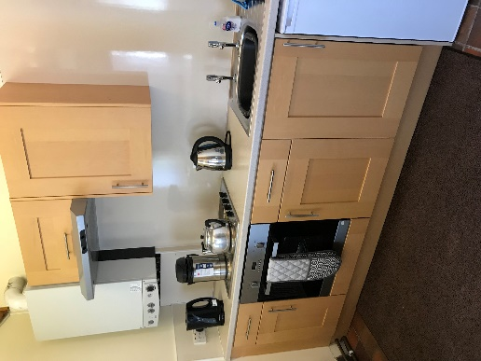
Washing up liquid, cloths and drying towels are provided.
A vacuum cleaner is available and you should bag and remove all of your waste.

Access:
Although there is a ramped entrance to the building, the toilet facilities are currently unsuitable for wheelchair access. The intruder alarm and security systems will be managed by the Trust and you should not adjust them.

Fire Plan:
Please read the Fire Action notice on the inside wall beside the front door. The Fire Exit and Fire Extinguishers are marked on the layout plan. The Fire Assembly Point is across Gannochy Avenue at the pedestrian gate to Dupplin Brae.

Parking:
Parking provision at the Hall is very limited and reserved for local tenants. Please drop off equipment and people by car and park in the Doo’cot Pavilion car park using the pedestrian crossings to walk back to the Hall.

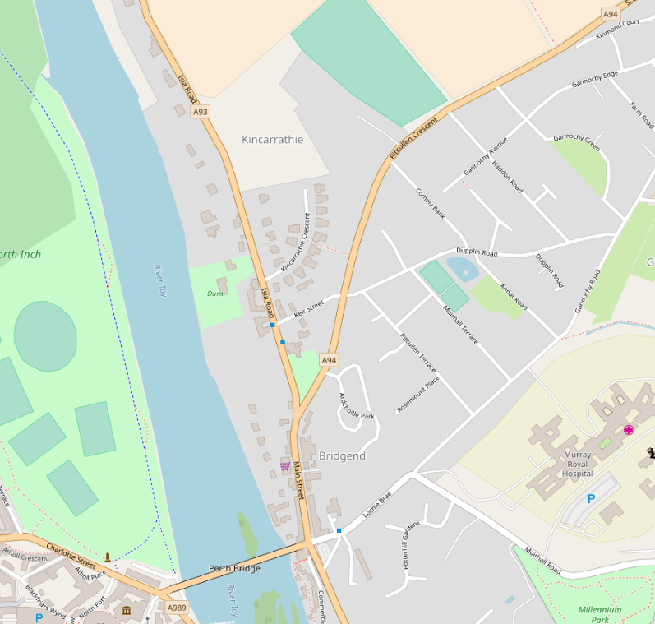
First Aid:
Gannochy Community Hall
Doo’cot Pavilion Car Park
Pedestrian Crossing
All users of the Hall are responsible for their own first aid provision. There is no phone in the Hall and users should ensure that they have access to a mobile phone in case of an emergency.

Location:
Gannochy Community Hall
Adjacent to 10 Gannochy Avenue
Perth
PH2 7JR

Booking:
Contact the Trust to enquire about availability or complete and return
a booking form.

