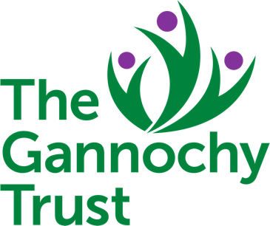
01

GANNOCHY TRUST FACILITIES – RISK ASSESSMENT FORM

Which Facility are you assessing risks for?
Please enter Quarrymill Woodland Park, Doo’cot Pavilion or Gannochy Community Hall.
Name of person completing Risk Assessment:
Date of assessment:

RISK LEVEL CALCUATOR
CONSEQUENCE | LIKELIHOOD
 | Unlikely | Possible | Likely
Slightly harmful | Trivial | Acceptable | Moderate
Harmful | Acceptable | Moderate | Substantial
Extremely harmful | Moderate | Substantial | Unacceptable

RISK LEVEL | CONTROL
Trivial or Acceptable |  | No further action required
Moderate |  | If it is reasonable to undertake some action to reduce the level of risk this should be done. If the risk is moderate because the consequences are extremely harmful, it is unlikely that there can be any further reduction without significant effort. Ensure there are suitable systems in place. Continue to monitor.
Substantial and Unacceptable |  | Action must be taken to remove or reduce the risk. If action cannot reduce or remove the level of risk, the activity should not be undertaken.

Describe the Potential Hazard | Risk Level BEFORE controls applied. | What need to be controlled to reduce the risk? | What actions will be taken by whom to achieve this? | Risk Level AFTER controls applied.
Example: Burns  or cuts in the kitchen. | Moderate | - Access to the kitchen by children  - Knives left unattended  - Kettles or hot drinks spilling or unattended | - Parents ensure children do not enter kitchen  - Jane ensures sharp knives and kettles stay in the kitchen  - Jane will ensure hot drinks/food are not left unattended | Acceptable
(Add as required)

