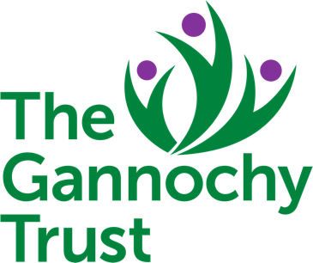
01

BOOKING FORM FOR USE OF:

Perth Doo’cot Cricket Pavilion or Gannochy Community Hall? _______________________________________________

SECTION 1 – YOUR CONTACT DETAILS:
Name:
Organisation
(If appropriate):
Address:
Tel. number (Day):
Tel. number (Eve):
Mobile (During event):
Email:

SECTION 2 – EVENT DETAILS:
From: | Date: | dd/mm/yy | Time: | 00:00 |  | To: | Date: | dd/mm/yy | Time: |  | 00:00
Please describe the event (e.g. Child’s Party, Community Meeting, Public Event, etc.) and if this is for regular or repeat events. Remember to include time for set up/tidy up.
How many people will be attending? |  |  |  |  | How many of these will be under the age of 18?
How will max numbers be controlled? (e.g. Invite only, ticket sales, door staff, other)

02

SECTION 3 – CAR PARKING:
Please refer to the Users Guidance Notes for the venue you are booking and describe the parking and travel advice you will be giving to those attending.

SECTION 4 – RISK ASSESSMENT:
Describe the plans that you have made to guard against risk, or attach a copy of your risk assessment form. You can request a Risk Assessment Template by contacting admin@gannochytrust.org.uk or 01738 620653.

SECTION 5 – PUBLIC LIABILITY INSURANCE:
Public Liability Insurance provides protection against claims made by members of the public for loss or injury. It isn’t a legal requirement, but it is good practice. Hire by individuals, for purposes unrelated to an organisation, will be covered by the Gannochy Trust Public Liability Insurance at no charge. Please tick one of the following:
A copy of our Public Liability Insurance certificate is attached or will be forwarded upon renewal
Our organisation has no Public Liability Insurance and understands the risks involved
I am booking as an individual for an event unrelated to an organisation

SECTION 6 – LETTING CHARGES:
Quarrymill Woodland Park and The Curly are provided by the Trust as a public amenity without a letting charge on a first come first served basis. Groups of 30 or more are requested to complete this application for use.

The Gannochy Community Hall and the Doo’cot Pavilion are provided by the Trust:
- For events that benefit the wider community, and for charities supported by the Trust in the last three years
without charge.
- For Gannochy residents to host private events at a rate of £15 per session.
- For other agencies at a rate of £30 per session.
The full cost of cleaning and/or damages will be recovered where necessary. Events for commercial gain will not be accommodated. Sessions are periods of approximately 3 ½ hours.
I am applying for a free let for a community event or am a charity supported by the Trust.
I am a Gannochy resident applying for a let for an event at £15 per session, please invoice me.
I am applying for a let at £30 per session, please invoice me.

03

SECTION 7 – DECLARATION:
The Gannochy Trust will not use your data for any other purpose other than processing your application to use facilities. Personal data will not be passed on to third parties, and will be deleted in accordance with The Gannochy Trust Privacy Policy Statement. You can request a copy of the Privacy Policy Statement by contacting admin@gannochytrust.org.uk.
By signing this form or submitting it by email, you are consenting to your data being retained for the purposes of processing this application for the use of a Gannochy Trust venue.
Please sign in box above (Emailed applications do not require a signature) | Date:

Please return your completed application to:
The Gannochy Trust
Pitcullen Crescent
Perth PH2 7HX

Or

admin@gannochytrust.org.uk

Please Email or Telephone for support

