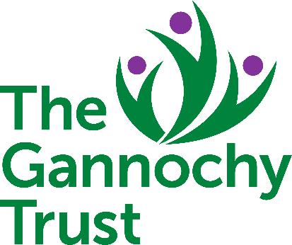

Grant Terms and Conditions

If you accept a grant from the Gannochy Trust it will be on the understanding that you have agreed:

- The Gannochy Trust outcome(s) that you aim to achieve
- The specific conditions or requirements contained within the Trust’s Grant Agreement
- The following general terms and conditions

If a conditional grant award has been made to you then you will be required to confirm that the conditions have been met before a formal Grant Agreement to release the funding can be made.

- The grant is awarded for the purpose detailed in the Grant Agreement.

- The Grant Agreement will be provided when all the conditions have been met. You should arrange for a Trustee of the charity to sign and date the Agreement before returning to the Trust, with your bank account details, to enable us to make your grant payment by BACS. A copy of the Agreement should be retained for your own records.

- No changes to the project should be made without our agreement. You must also inform us immediately of any proposed change relating to grant expenditure or the organisation. If the timing of a project slips or the project is likely to fail for whatever reason, you should also inform the Trust. The Trust will consider any reasonable variation or alternative.

- You should complete the Grant Report Template at the end of your project or at the end of each year of the grant depending on which is the sooner. We will also require a copy of your annual report and accounts for each financial year during the period of the grant. If you are in receipt of a multi-year grant, the release of the next payment is dependent upon the receipt of a satisfactory report.

- You should keep accurate records of the expenditure relating to the grant and submit these with your progress report at the end of the project or at the end of each grant year. A combined template for both the project report and the financial information can be found at: www.gannochytrust.org.uk on the grant-making page.

- If during the course of the grant period there is an under-spend on the project then we would expect you to write to the Trust. At which time the Trust will consider any reasonable variation or alternative for the residual grant (including whether the balance of funding should be returned).

- The grant should be acknowledged in all printed materials that you produce about the work for which you have received funding and acknowledged elsewhere such as within your annual report and accounts. If you would like to use our logo, this can be emailed to you by contacting grants@gannochytrust.org.uk If the grant is to be acknowledged within a press release or any other type of media coverage we would be grateful if you could contact the Trust Office for approval.

- Please note that the Trust reserves the right to withhold a grant or require repayment if:

  - we find that any false information is deliberately supplied to the Trust;
  - the work undertaken is not the work for which the grant was approved;
  - your organisation becomes insolvent or goes into administration, receivership or liquidation, and if the grant has not already been spent on its intended purpose.

- Visits to charities and projects help assist us to gain a clearer picture of the difference that our grant is making to the outcome of a project. If we would like to visit your project in connection with our grant then this would be agreed with you in advance.

- If you have any questions regarding the above please do not hesitate to contact the Gannochy Trust Office.

